BIRFC will provide Immediate Care Providers for:
- Ironsides Men’s Senior Teams (1st, 2nd, 3rd, 4th ,5th & Vets)
- Ironsides Women’s Senior Teams (1st, 2nd)
- Ironsides Youth teams based at Garrett Green (U15, U16, COLTS)
The priority order, for immediate care provision will be:-
- Senior Home Games (Men’s & Women teams)
- U15, U16 & COLTS Home Games
- Senior Away Games

Immediate Care Providers will be in addition to requirement for U15, U16 & COLTS teams to provide Adult 1st Aid Volunteers, their presence being to provide expert immediate support in the event of player’s suffering a serious injury.

Appendix.
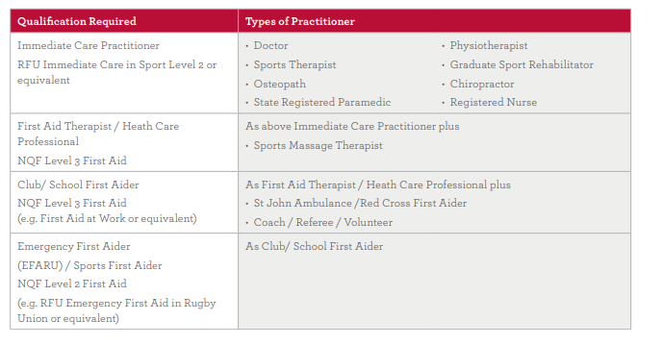
References: https://www.englandrugby.com/rugbysafe/playing-environment/first-aid-immediate-care-guidelines
Author: ACW: 24th Feb, 2019

